MASP INSTRUCTIONS
Pages 1-10 require total completion for regional office review and approval signatures (page 1 through aerial hazard analysis and map). Pages 11-14, which includes, pilot information, flight following, frequencies, MTR’s, MOA’s, crash rescue and medivac plans, may be completed as information becomes available. Partial completion of these pages is recommended during the submission process and all pages shall be completed prior to mission start.
RISK MATRIX INSTRUCTIONS
Risk assessment processes and risk decision approvals follow the guidelines set forth in the Aviation Risk Management Workbook, aka the “yellow book,” National Aviation Safety Management System Guide, and the Operation Risk Management Guide. The risk outcomes on the risk assessment matrix (page 5) have been incorporated into the risk assessment worksheet’s drop-down menus. Risk Assessment Category (RAC) outcomes are categorized as follows:
Low Moderate High Extremely high
In no case will the overall risk of the mission be less than the highest specific factor. (Example: One extremely high, one high, and two moderate threats results in an extremely high risk assessment category outcome).
SIGNATURES
Route all MASP’s through the Unit/Forest Aviation Officer for Regional Office review. Signature blocks on page 2 are listed in the order required for MASP approval. The MASP’s will be routed back down through the Unit/Forest Aviation Officer (AO) for line officer approval. MASPs will be submitted as a word document and will be returned in PDF format for the approving official’s signature.
All signature boxes up to the Aviation Officer will be signed in typed text:
Example: /s/ John M. Smith
The Regional Aviation Safety Manager (RASM) and the Regional Aviation Officer (RAO) will sign with link pass digital signatures, if possible, otherwise as stated above. Line officer signatures may sign with a wet signature or link pass digital signature at their discretion.
RETENTION AND FILING OF PLAN
MASPs that have been reviewed by the Regional Office will remain in Pinyon and archived by fiscal year. These plans are accessible by the Regional Office, Unit/Forest Aviation Officers, and select aviation managers. Plans approved by the line officer will be maintained in the dispatch office and referenced during flight. Retention of the safety plan by dispatch shall be one year. Retention of the plan and daily briefing sheets by the mission manager shall be one year.
Unit: Click here to enter text. | Sub Unit: Click here to enter text.

Agency Requesting Mission  FS NPS BLM  FWS BIA  STATE OTHER |  |  | Anticipated Date(s): YES NO Calendar Year: YES NO  *Use start and end date below only if anticipated date(s) box is selected* |  | Calendar Year  Choose an item.
Aircraft Type
Fixed | Rotor | UAS | Start Date | End Date | MASP Objectives
 |  |  | Click here to enter a date. | Click here to enter a date. | Training Resource LE&I Mission Incident

Mission prepared by: Click here to enter text. | Title: Choose an item. | Click here to enter a date.
Mission reviewed by: (OPTIONAL) Unit Level: Click here to enter text. | Title: Choose an item. | Click here to enter a date.
Mission reviewed by: (OPTIONAL) Regional Level: Click here to enter text. | Title: Choose an item. | Click here to enter a date.
Mission reviewed by: (REQUIRED) Aviation Officer: Click here to enter text. | Title: Choose an item. | Click here to enter a date.
Mission reviewed by: (REQUIRED) RASM: | Title: Regional Aviation Safety Manager | Click here to enter a date.
Mission reviewed By: (REQUIRED) RAO: | Title: Regional Aviation Officer | Click here to enter a date.
Mission and Risk Assessment approved by: (REQUIRED) - Line Officer: | Title: Choose an item. | Click here to enter a date.

* Participant’s qualifications and responsibilities shall be verified and discussed during daily briefing*
Aviation Manager (IAW IAT Guide):  Click here to enter text. | Alternate Aviation Manager (IAW IAT Guide):  Click here to enter text.
Mission Name
Click here to enter text.
Mission Description and Location: Click here to enter text.
Mission Objectives: Click here to enter text.
Aircraft Justification For Mission: Click here to enter text.

Aircraft Information:
*Check all that apply, if name is unknown, add information as it becomes available*
*Leave text fields blank if unknown*
*All cooperators require an annual approval letter onboard except DOJ aircraft*
Cooperator: Click here to enter text. Agency: Click here to enter text.
Vendor: Click here to enter text. Military: Click here to enter text.
Other: Click here to enter text.
Rotor Wing: Type One: Type Two: Type Three:
*Document additional requirements beyond standard typing in aircraft justification and on the resource order* (performance capabilities, equipment, etc.).
Fixed Wing: Single Engine Twin Engine
*Document mission needs for turbine, twin-engine, air conditioning, high or low wing, pressurized cabin, radio package, etc. in the aircraft justification section and on the resource order.*
UAS: Fixed Wing Rotory Wing (VTOL)
Aircraft Make and Model: If unknown, add information as it becomes available. All information shall be filled out prior to mission start.
Unknown CWN: Unknown EU:
Vendor: Click here to enter text. FAA Registration #: Click here to enter text.
Make: Click here to enter text. Model: Click here to enter text.
Carded for Mission: YES NO Card Expiration Date: Click here to enter text.
Aircraft Color Scheme: Click here to enter text.
** CWN helicopter information attained after hiring process, ensure CWN inspection sheet has been completed and a copy of the aircraft data card is on file prior to mission start. **
Procurement and Cost Information: Check unknown if unable to provide accurate or estimated information.
Procurement Type: Choose an item.  Unknown  Missioned Flight Hours: Click here to enter text.  Unknown  Charge Code: Click here to enter text.  Unknown | Estimated Flight Hour Cost: Click here to enter text.  Unknown  Estimated Miscellaneous Cost(s): Click here to enter text.  Unknown

UAS Missions Only
Crew: Other Than Pilot: Pilot information found on page 12.
UAS Crew Leader: Click here to enter text. Contact Number: Click here to enter text.
UAS Data Specialist (1): Click here to enter text. Contact Number: Click here to enter text.
UAS Data Specialist (2): Click here to enter text. Contact Number: Click here to enter text.
UAS Visual Observer (1): Click here to enter text. Contact Number: Click here to enter text.
UAS Visual Observer (2): Click here to enter text. Contact Number: Click here to enter text.
Additional Crew: Click here to enter text. Contact Number: Click here to enter text.
TFR Information: Click here to enter text.
Airspace Authorization:
Part 107 107/LAANC SGI Waiver FAA/DOI MOA
Authorization Comments - Click here to enter text.
Lost Link and Flyaway Procedures-Protocols:Click here to enter text.
Special Consideration-Safety Concerns-Comments Section:Click here to enter text.

**Risk assessment must be completed prior to mission approval**
**Risk assessment hazards shall be reassessed prior to starting the mission, see FRAT**
**Ensure appropriate management level for approval **
**See the National Aviation Safety Management System Guide, Yellow Book, and ORM guide for additional guidance with Risk Assessments
**This Risk Assessment does not negate the requirement to complete a FRAT prior to flight. **

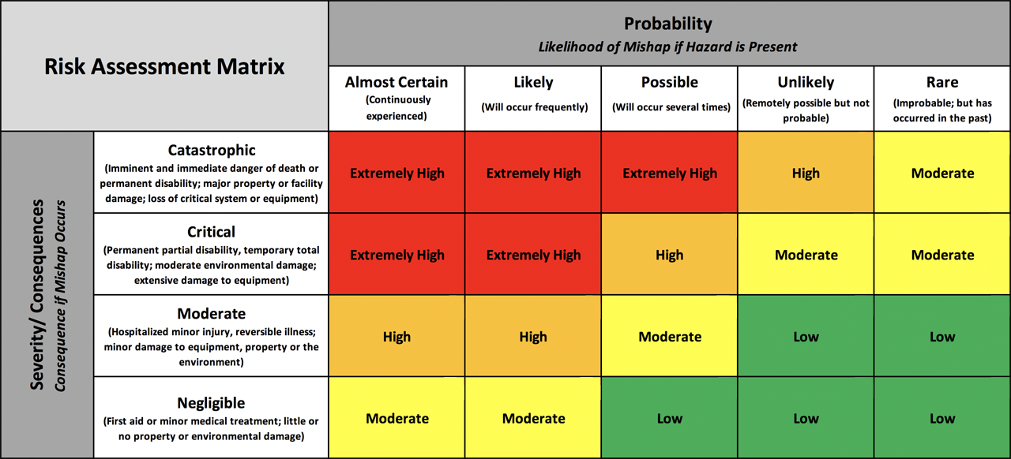

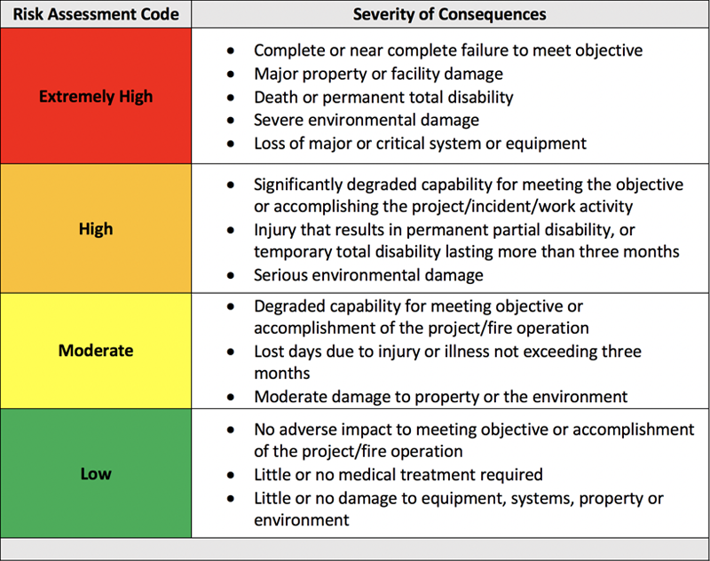

Risk Decision Authority
Risk Level | Fire | Mission
Extremely High | Incident Commander or Operations Sections Chief | Line Officer
High | Incident Commander or Operations Sections Chief | Line Officer
Moderate | Air Operations Branch Director | Supervisor or Lead
Low | Base Manager | Individual

SAFETY MANAGEMENT SYSTEM ASSESSMENT AND MITIGATION
System Being Evaluated: Click here to enter text. |  | Pre Mitigation |  |  |  | Post Mitigation
Sub System(s) | Hazards | Likelihood | Severity | Risk Level | Mitigation | Likelihood | Severity | Risk Level
Click here to enter text. | Click here to enter text. | Choose an item. | Choose an item. | Choose an item. | Click here to enter text. | Choose an item. | Choose an item. | Choose an item.
Click here to enter text. | Click here to enter text. | Choose an item. | Choose an item. | Choose an item. | Click here to enter text. | Choose an item. | Choose an item. | Choose an item.
Click here to enter text. | Click here to enter text. | Choose an item. | Choose an item. | Choose an item. | Click here to enter text. | Choose an item. | Choose an item. | Choose an item.
Click here to enter text. | Click here to enter text. | Choose an item. | Choose an item. | Choose an item. | Click here to enter text. | Choose an item. | Choose an item. | Choose an item.
Click here to enter text. | Click here to enter text. | Choose an item. | Choose an item. | Choose an item. | Click here to enter text. | Choose an item. | Choose an item. | Choose an item.
Click here to enter text. | Click here to enter text. | Choose an item. | Choose an item. | Choose an item. | Click here to enter text. | Choose an item. | Choose an item. | Choose an item.
Click here to enter text. | Click here to enter text. | Choose an item. | Choose an item. | Choose an item. | Click here to enter text. | Choose an item. | Choose an item. | Choose an item.
Click here to enter text. | Click here to enter text. | Choose an item. | Choose an item. | Choose an item. | Click here to enter text. | Choose an item. | Choose an item. | Choose an item.
Click here to enter text. | Click here to enter text. | Choose an item. | Choose an item. | Choose an item. | Click here to enter text. | Choose an item. | Choose an item. | Choose an item.
Click here to enter text. | Click here to enter text. | Choose an item. | Choose an item. | Choose an item. | Click here to enter text. | Choose an item. | Choose an item. | Choose an item.
Click here to enter text. | Click here to enter text. | Choose an item. | Choose an item. | Choose an item. | Click here to enter text. | Choose an item. | Choose an item. | Choose an item.
Click here to enter text. | Click here to enter text. | Choose an item. | Choose an item. | Choose an item. | Click here to enter text. | Choose an item. | Choose an item. | Choose an item.
Final Assessment:  Low Moderate High Extremely High |  | Click here to enter text. |  |  | Click here to enter a date.
**Add Additional Rows to Risk Assessment as Necessary**

Aerial Hazard Analysis and map: Provide a written analysis of aerial hazards surrounding the mission area in this box, e.g. towers, wires, sloping terrain, dust, proximity to airports, confined landing zones, etc. Replace the blue box below with a hazard map or include map at the end of the MASP.

Aircraft Performance Planning:
The pilot is responsible for the accurate completion of load calculations or PPC (military performance planning). Trained personnel shall ensure that aircraft scheduled are capable of performing the mission(s) safely and within the capabilities of the aircraft selected. The helicopter or flight manager shall ensure that manifests, load calculations, weight & balance are completed properly using accurate environmental and aircraft data. Reference SHO chapter 7 or chapter 70 of the Military Use Handbook for additional information.

Personal Protective Equipment: *Always refer back to current ALSE, SHO, and manual direction*
Type of Operation- Check applicable boxes that may apply to mission or mission | Personnel protective equipment requirements
Rotor Wing Ground Operations | Fire resistant clothing, hard hat w/chin strap or SPH-5 flight helmet or other approved model, fire resistant and/or leather gloves, all leather boots, eye protection, hearing protection. *Refer to the Interagency Aerial Ignition Guide for additional ground operation requirements.*
Rotor Wing | Fire resistant clothing, approved flight helmet, hard hat w/chin strap, fire resistant and/or leather gloves, approved leather or flight boots, eye protection, hearing protection. Additional personnel restraints needed in the helicopter pending type of mission. * Refer to appropriate guides. * Charter flights, (non-agency controlled mission), shall comply with 14 CFR 135 requirements.
Doors Off Flight(s) | Personnel will remain seated and inside fuselage during all flights, approved secondary restraint harness for doors off flights (only for PLDO, HRAP, HRSP, Aerial Photography, IR Operator, ACETA Gunner, Cargo Letdown, Short Haul Spotter, Cargo Free Fall Operations in type 3 helicopter) * Refer to appropriate guides*
Cargo Free Fall Operations | Fire resistant clothing, SPH-5 flight helmet or other approved model, fire resistant and/or leather gloves, all leather boots, eye protection, hearing protection. Additional qualifications, compliance with rotorcraft manual and approved restraint requirement apply. * Refer to SHO chapter eleven for additional details. *
Fixed Wing | Refer to current IASG, ALSE and 5700 manual directions for PPE requirements.

Helicopter or fixed Wing Pilot Information: Fixed wing: use “other” box and state approved mission(s). Any unknown information shall be added after signature approvals. All personnel shall be qualified for mission or designated as a trainee with appropriate oversight.
Pilot Name (P1): PIC/Primary  Click here to enter text. | Pilot Phone Number:  Click here to enter text.
Pilot Name (P2): Co-Pilot/Relief  Click here to enter text. | Pilot Phone Number:  Click here to enter text.
Pilot Carded For Mission: Yes No  Charter Pilot 135 Certificate and FAR’s Apply  ** Use of charter pilot requires regional forester approval**  Check all boxes that apply to pilot’s carding below: | Pilot Card (P1) Expiration Date:  Click here to enter a date.  Pilot Card (P2) Expiration Date:  Click here to enter a date.
Low-Level Recon & Survey P1 P2  Helitack-Passenger Transport P1 P2  External Load (Belly Hook) P1 P2  Water-Retardant Delivery P1 P2  Longline VTR (150’) P1 P2  Snorkel: VTR Mirror P1 P2  Mountainous Terrain Flying P1 P2  Aerial Ignition (PSD) P1 P2  Aerial Ignition (Torch) P1 P2  Rappel Operations P1 P2  Cargo Letdown P1 P2  Snow Operations (Deep Snow) P1 P2  Hoist P1 P2  UAS P1 P2 | Designated “Pilot Trainer” P1 P2  “Trainee Only” Pilot P1 P2  Short Haul LE SAR P1 P2  Float Operations (Fixed) P1 P2  Platform Landings-Offshore P1 P2  Vessel Landings P1 P2  NVG Operations P1 P2  ACETA Net Gun (All ACETA) P1 P2  ACETA Eradication P1 P2  ACETA (Herding) P1 P2  ACETA Darting-Paintball P1 P2  STEP P1 P2  Other P1 P2  Click here to enter text.

Flight Following And Frequencies:
*Confirm frequencies prior to flight*
*FAA Flight Plan (chartered aircraft non-agency-controlled mission) no frequencies required*
*Chartered 135 operator is responsible for communications and flight plan*
Flight Following Method: AFF Radio (Local or GACC aircraft desk)
FAA Flight Plan: (Agency-owned or agency contracted aircraft mission)
FAA Flight Plan: (Charter aircraft non-agency controlled mission)
FM Receive: Click here to enter text. | FM Transmit: Click here to enter text. | RX: Choose an item.  TX: Choose an item.
FM Receive: Click here to enter text. | FM Transmit: Click here to enter text. | RX: Choose an item.  TX: Choose an item.
FM Receive: Click here to enter text. | FM Transmit: Click here to enter text. | TX: Choose an item.  RX: Choose an item.
AM Receive: Click here to enter text. | AM Transmit: Click here to enter text. | No Tone
**Aviation Manager will coordinate Temporary Flight Restrictions (TFR) with dispatch if needed**
Military Training Route(s) (MTR’S) or Military Operating Area(s) (MOA’S)
Aviation Manager shall confirm deconfliction in these routes and areas prior to the flight with dispatch or other approved local methods.
Deconfliction will be discussed prior to mission start. Add Additional MTR-MOA information to the end of the document if necessary.
MTR-MOA | Route Legs-Altitudes | Activity | Time | Time Zone
Click here to enter text. | Click here to enter text. | Hot  Cold  N/A | Start: Click here to enter text.  Stop: Click here to enter text. | UTC  Local
Click here to enter text. | Click here to enter text. | Hot  Cold  N/A | Start: Click here to enter text.  Stop: Click here to enter text. | UTC  Local

Crash Rescue/Medivac Plan: Additional medical information attached? YES NO
General Instructions (in the event of an incident): Mission site duties and actions to be coordinated through dispatch in accordance with local search & rescue (SAR) and emergency crash rescue plan(s). These items will be discussed and recorded during the daily safety briefing.
Specified crash rescue duties will be assigned to ground operations personnel each day before flights of any kind. Crash rescue and first aid equipment will be located near the helicopter operations site, and equipment’s location made known to all personnel. Information and instructions will be sent/ received through the local dispatch office or communications.
EMT(s) on site: YES NO
Names: Click here to enter text.
First responder(s) on site: YES NO
Names: Click here to enter text.
Available medivac helicopters: YES NO UNKNOWN
*Unknown: Select if medivac helicopter won’t be ordered for the mission or incident prior to need. The helicopter will be ordered on demand through the dispatch process. Dispatch will provide medivac ship call sign or tail number, including capabilities and contact information. *
Medivac helicopter on site? YES NO
Level of care medivac personnel can provide: ALS BLS Unknown
FAA Tail #(s) Click here to enter text. | Contact Information: Click here to enter text.
Hoist/Rappel/Extraction Capable? YES NO
Check all that apply: Hoist Rappel Short Haul
MEDICAL FACILITY  Click here to enter text. | Name/Location/Helipad Information  Click here to enter text. |  | Helipad  YES NO
Latitude Click here to enter text. | Longitude Click here to enter text. | Contact Freq. Click here to enter text.
MEDICAL FACILITY  Click here to enter text. | Name/Location/Helipad Information  Click here to enter text. |  |  | Helipad  YES NO
Latitude Click here to enter text. | Longitude Click here to enter text. | Contact Freq. Click here to enter text.
NEAREST BURN FACILITY  Click here to enter text. | Name/Location/Helipad Information  Click here to enter text. |  |  |  | Helipad  YES NO
Latitude Click here to enter text. | Longitude Click here to enter text. | Contact Freq. Click here to enter text.

Doors Off or Doors Open Flight(s) | Personnel will remain seated and inside fuselage during all flights, approved secondary restraint harness for doors off flights (only for PLDO, HRAP, HRSP, Aerial Photography, IR Operator, ACETA Gunner, Cargo Letdown, Short Haul Spotter, Cargo Free Fall Operations-type 3 helicopter) * Refer to appropriate guides*  **Safety Alert IASA 18-03 language**  “Agency personnel involved in any public aircraft operations mission that require aircraft doors to be removed prior to flight, or open during flight, shall receive hands-on secondary restraint refresher training prior to conducting flight operations”.
Doors Off or Open Operations checklist: **All items shall be covered and signed for prior to operations**
Aircraft connection point and secondary restraint configuration (Interagency Safety Alert IASA 17-02)
Proper donning and adjustment of secondary restraint system.
Have an understanding of the secondary restraint interaction with FAA approved seat belts.
Potential of secondary restraint interference with Airbus AS 350 fuel shut off lever if applicable.
Know location and use of secondary restraint interaction quick- release.
Perform buddy–check and Pilot in Command check of secondary restraints before flight.
Practice egress with secondary restraint quick-release mechanism and function of seatbelt.
Know location and use of rescue knife.

Vendor Name: | Aircraft Model: | Aircraft Make: | FAA#:
Aviation Manager: | Date: | Pilot: | Date:

Participants Name | Date | Participants Name: | Date
**Use back of this form if needed for additional participants name and date.**

